Data Visualisation Assignment

Lal Singh Dhaila (18304211)

Night ingales’s Nose

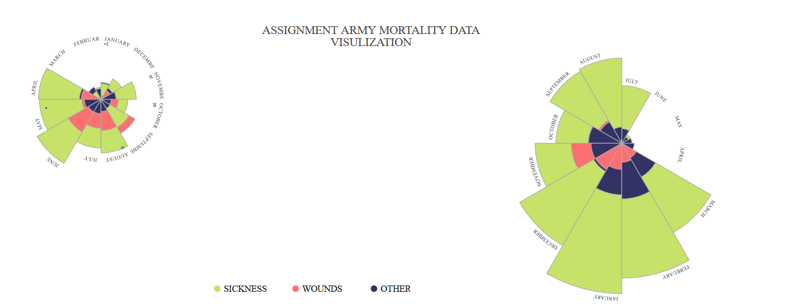

GitHubLink: https://github.com/lsd198/datavisproject.git

Minard’s Map

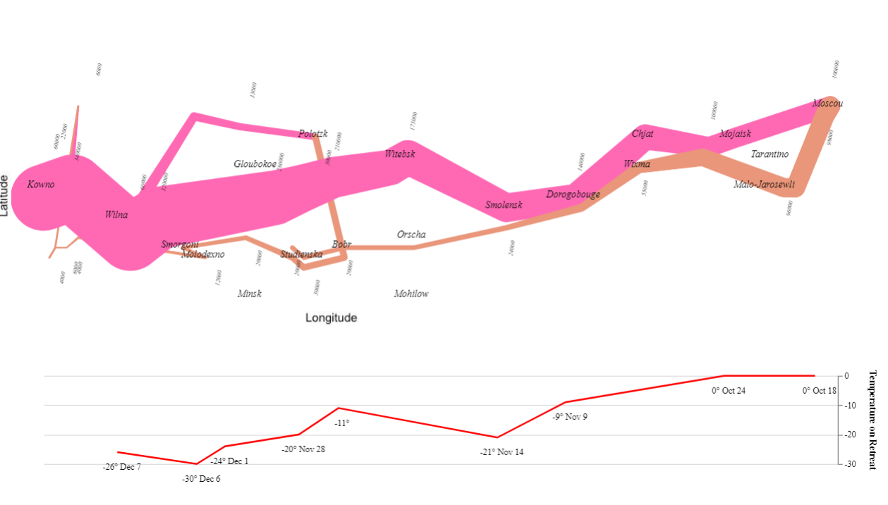

GitHubLlink: https://github.com/lsd198/datavisproject.git

Minard’s Visualization Report

1. Data Visualization for Napoleon army retreat, where the size of army got reduced.
2. Visualization provided is created using the Python.
3. Data set used is the one provided by the lecturer.
4. Libraries used for the visualization purpose:
   1. NumPy
   2. Pandas
   3. Altair
   4. Vga_datasets
5. For visualization purpose I have divided the data into three data sets each one is consisting of below details:
   1. Cities dataset
   2. Temperature dataset
   3. Troop data set
6. Data correlation have been made with the data provided so that we can visualize how the temperature is affecting size of the Napoleon army
7. The pink line in the above graph is showing the advancing scenario where the initial size of the army is 340000.
8. The light brown line shows the retreating army size decreasing due to the weather condition, the final size of army remaining after retreat is 4000
9. Second plot shows the date and the temperature when the army is retreating from the war.